CMPG325 INDIVIDUAL SEMESTER PROJECT
FINAL SUBMISSION:
LT KOBE 45532206
Project ID: CMPG325-2026-023 | Client: Thuto Skills Training College (Klerksdorp) | Client ID: CLI-023
github.com/lisamateane/thuto-college-network

1. Introduction and Project Overview
This report documents the design, implementation and testing of a computer network for Thuto Skills Training College in Klerksdorp. The network was designed and simulated in Cisco Packet Tracer as part of the CMPG325 individual semester project.
The project had three fixed elements assigned in the brief:
- Assigned networking challenge: VLAN Trunking (802.1Q across switches), classified as Advanced.
- Design constraint: The boardroom requires dedicated wireless and wired presentation ports.
- Client change request: One off-site administrator requires secure remote management access to network devices.
The network uses the assigned addressing block 10.18.0.0/16. It was delivered in three stages: Milestone 1 which consists of the client requirements, assumptions, IP addressing plan and topology design, Milestone 2 which consists of Packet Tracer implementation, testing and troubleshooting, as well as the final submission which consists of the Packet Tracer file, this technical report, a GitHub portfolio of evidence and a video demonstration.

2. Client Requirements
The client requirements come directly from the project brief:
- Use Cisco Packet Tracer for the implementation and simulation.
- Use the assigned addressing block 10.18.0.0/16 as the basis of the IP addressing plan.
- Provide appropriate connectivity and network services for the assigned scenario.
- Configure the necessary routers, switches, end devices and other required nodes.
- Accommodate the design constraint and the change request.
- Demonstrate successful connectivity and testing.
- Document significant design decisions and evidence in GitHub.
Testing requirements: test relevant end-to-end connectivity, verify the assigned networking challenge, capture clear evidence of successful operation, document important troubleshooting and ensure the final .pkt file opens and reproduces the working solution.

3. Design Assumptions
The brief does not specify exact departments, device counts or room layout for Thuto Skills Training College. Following the lecturer’s guidance, assumptions were made where the brief is silent and are documented in this section rather than presented as official client requirements.
Assumed departments
- Administration Office: staff handling registration, finance and admin tasks. It has its own VLAN so staff traffic is isolated.
- Student Computer Lab: shared student PCs that are kept separate from Admin so student traffic cannot affect staff systems.
- Boardroom: used for meetings and presentations. The brief requires wired and wireless presentation ports, so it has its own VLAN and an access point.
- IT/Server Room: houses the core equipment which are the router and switches.
Assumed device counts
- Admin: about 20 staff PCs
- Labs: about 40 student PCs
- Boardroom: about 5 wired and wireless devices
- Management: the router and switches
Remote administration method (CR9)
CR9 requires secure remote management but does not name a protocol. SSH was chosen over Telnet because Telnet sends credentials in plain text. A dedicated Management VLAN (VLAN 99) keeps device management separate from user traffic.
Two switches
Two switches were used so that 802.1Q trunking between switches has a genuine and demonstrable purpose.

4. IP Addressing Plan
The assigned block is 10.18.0.0/16. It was divided into four /24 subnets, one per VLAN and all inside the assigned range.
VLAN ID | VLAN Name | Subnet | Usable Range | Gateway
10 | Admin | 10.18.10.0/24 | 10.18.10.1 – 10.18.10.254 | 10.18.10.1
20 | Labs | 10.18.20.0/24 | 10.18.20.1 – 10.18.20.254 | 10.18.20.1
30 | Boardroom | 10.18.30.0/24 | 10.18.30.1 – 10.18.30.254 | 10.18.30.1
99 | Management | 10.18.99.0/24 | 10.18.99.1 – 10.18.99.254 | 10.18.99.1

Why /24 subnets?
A /24 gives 254 usable addresses, which comfortably covers the assumed device counts with room to grow. It also keeps the plan simple to explain and verify.
Why each VLAN exists?
- VLAN 10 (Admin): isolates staff traffic from student traffic.
- VLAN 20 (Labs): keeps student PCs away from administrative systems.
- VLAN 30 (Boardroom): supports the wired and wireless presentation constraint.
- VLAN 99 (Management): a dedicated network for managing the router and switches which supports CR9.
Gateways: The router holds the gateway address for every VLAN, using router-on-a-stick subinterfaces.

5. Network Topology
5.1 Physical topology. The network has one router (HQ-ROUTER), two switches (CORE-SW and ACCESS-SW), one access point (BOARD-AP) and the end devices in each department.
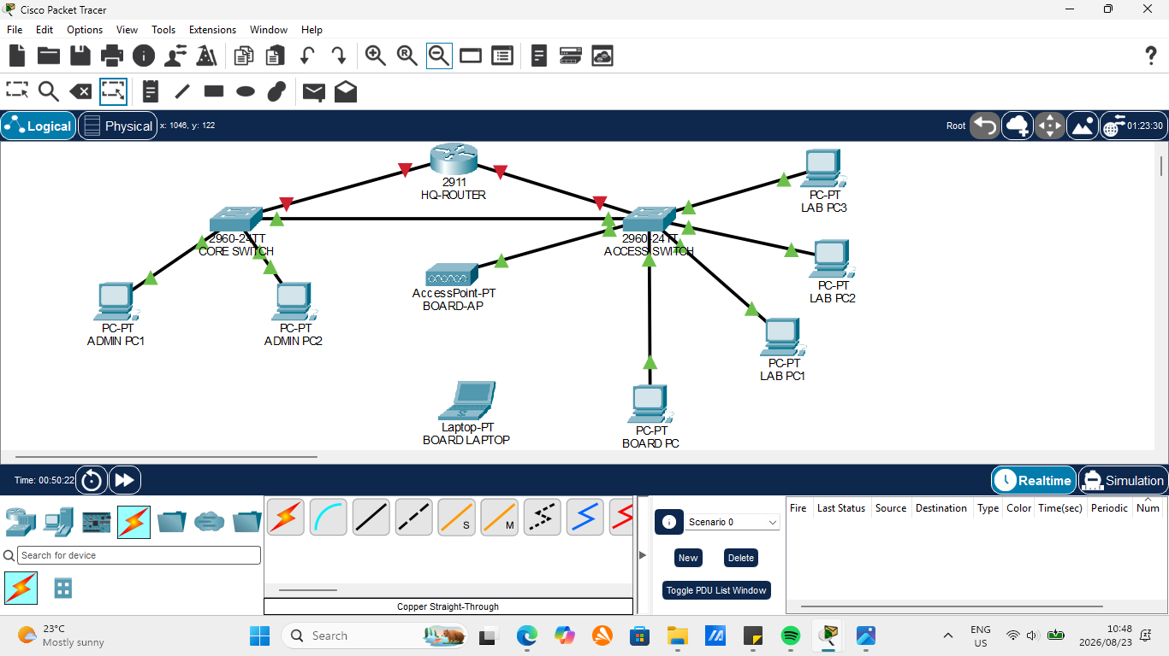
Figure 1: Physical topology
5.2 Logical topology. The logical topology shows how the VLANs and subnets are arranged and how traffic is routed between them.
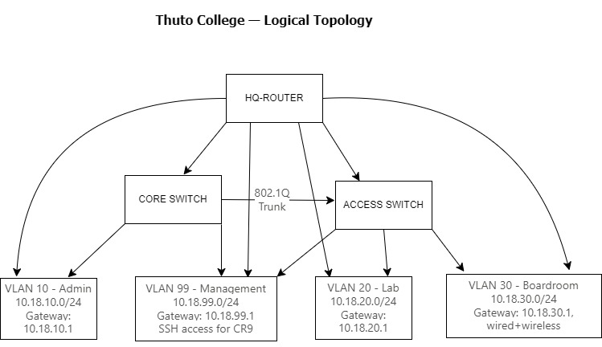
Figure 2: Logical topology

6. Implemented Network
Cabling and port use:
- HQ-ROUTER Gig0/0 to CORE-SW Fa0/1: trunk carrying all VLANs to the router
- CORE-SW Fa0/2 to ACCESS-SW Fa0/2: 802.1Q trunk between the switches
- HQ-ROUTER Gig0/1 to ACCESS-SW Fa0/1: spare link from the Milestone 1 topology, not needed for the router-on-a-stick design, left administratively shut down
- Admin PC1 and Admin PC2 on CORE-SW Fa0/3 and Fa0/4: VLAN 10
- Lab PC1, PC2 and PC3 on ACCESS-SW Fa0/5, Fa0/6 and Fa0/7: VLAN 20
- BOARD-AP on ACCESS-SW Fa0/8 and Board PC on ACCESS-SW Fa0/9: VLAN 30
- Board Laptop connects wirelessly to BOARD-AP
Device addressing:
Device | VLAN | IP address | Gateway
Admin PC1 | 10 | 10.18.10.10 | 10.18.10.1
Admin PC2 | 10 | 10.18.10.11 | 10.18.10.1
Lab PC1 | 20 | 10.18.20.10 | 10.18.20.1
Lab PC2 | 20 | 10.18.20.11 | 10.18.20.1
Lab PC3 | 20 | 10.18.20.12 | 10.18.20.1
Board PC | 30 | 10.18.30.10 | 10.18.30.1
Board Laptop (wireless) | 30 | 10.18.30.11 | 10.18.30.1
HQ-ROUTER (management) | 99 | 10.18.99.1 | n/a
CORE-SW (management) | 99 | 10.18.99.2 | 10.18.99.1
ACCESS-SW (management) | 99 | 10.18.99.3 | 10.18.99.1
All subnets use the mask 255.255.255.0.
Differences from Milestone 1:
Milestone 1 listed the access point among the management devices. In the implementation BOARD-AP is an access port in VLAN 30 with no VLAN 99 address because remote management was implemented on the router and the two switches, which meets CR9. The configurations on all three devices were saved with copy running-config startup-config.
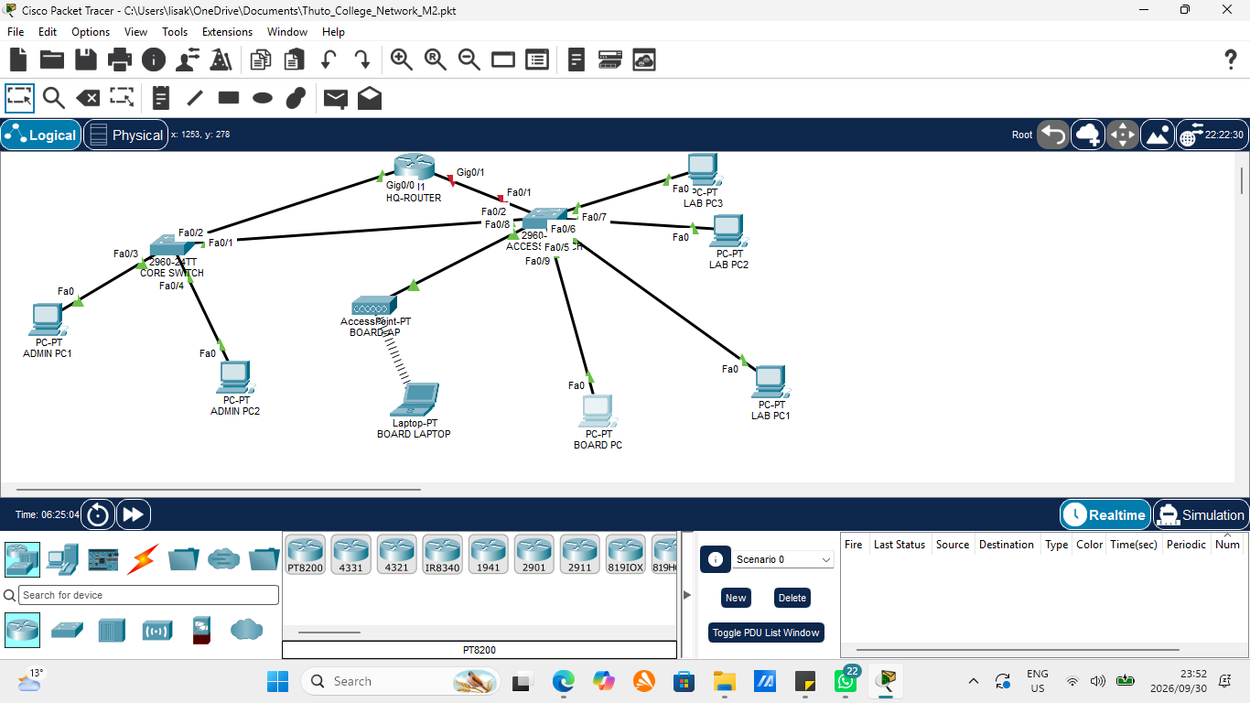
Figure 3 : Final Packet Tracer topology

7. Assigned Challenge: VLAN Trunking (802.1Q)
What was configured. VLANs 10, 20, 30 and 99 were created on both switches and the access ports were assigned to their VLANs. The link between CORE-SW and ACCESS-SW was set up as an 802.1Q trunk on both ends, allowing only VLANs 10, 20, 30 and 99.
Commands on CORE-SW (ACCESS-SW uses the same VLAN commands):
vlan 10
name Admin
vlan 20
name Labs
vlan 30
name Boardroom
vlan 99
name Management
interface range fa0/3-4
switchport mode access
switchport access vlan 10
interface range fa0/1-2
switchport mode trunk
switchport trunk allowed vlan 10,20,30,99
Commands on ACCESS-SW (ports and trunk):
interface range fa0/5-7
switchport mode access
switchport access vlan 20
interface range fa0/8-9
switchport mode access
switchport access vlan 30
interface fa0/2
switchport mode trunk
switchport trunk allowed vlan 10,20,30,99
Why it is appropriate?
Devices from the same departments are spread across two switches, so a single cable between the switches has to carry traffic for several VLANs at once. 802.1Q tagging does this while keeping the VLANs separate. Limiting the allowed VLAN list keeps unused VLANs off the link.
How it was verified.
show vlan brief confirmed the VLANs and port assignments on both switches. show interfaces trunk confirmed trunk mode, 802.1q encapsulation, trunking status and VLANs 10, 20, 30 and 99 in the allowed, active and forwarding lists on both ends. A routed ping and tracert across the trunk confirmed that traffic passes between the switches.
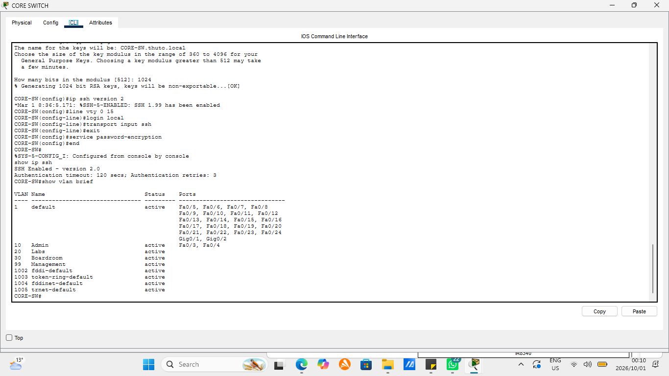
Figure 4: show vlan brief on CORE-SW (M2-07)
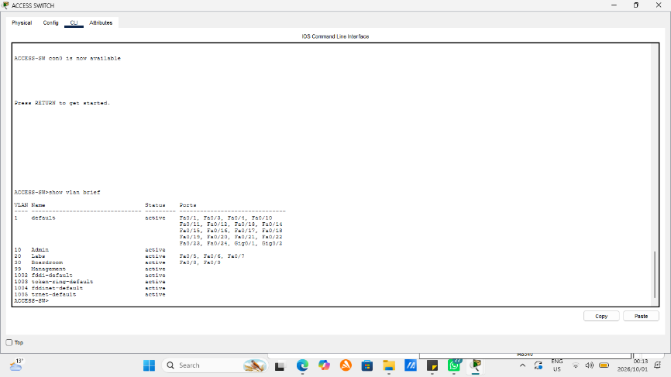
Figure 5: show vlan brief on ACCESS-SW (M2-08)
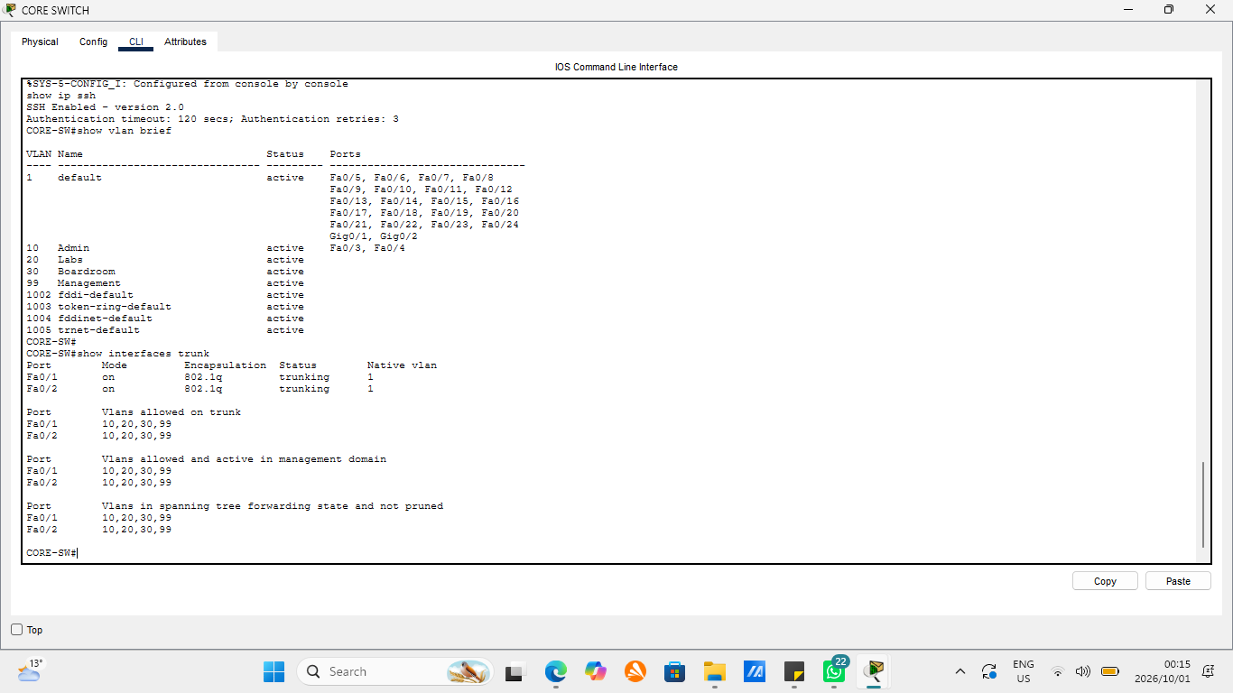
Figure 6: show interfaces trunk on CORE-SW (M2-09)
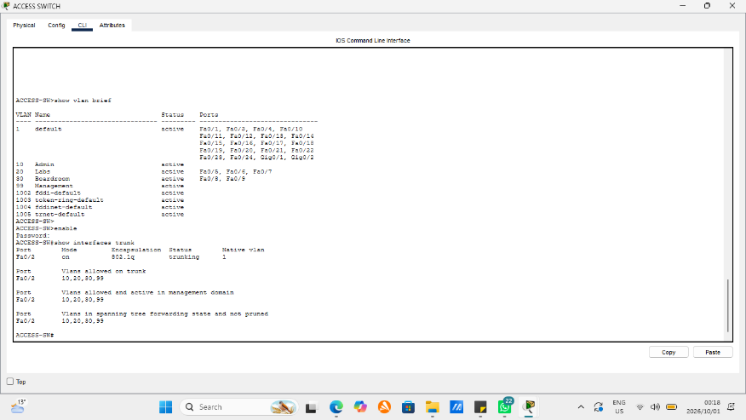
Figure 7: show interfaces trunk on ACCESS-SW (M2-10)

8. Inter-VLAN Routing
Routing between VLANs uses router-on-a-stick. HQ-ROUTER Gig0/0 is divided into one subinterface per VLAN, each using 802.1Q encapsulation and holding that VLAN’s gateway address.
interface gigabitEthernet0/0
no shutdown
interface gigabitEthernet0/0.10
encapsulation dot1Q 10
ip address 10.18.10.1 255.255.255.0
interface gigabitEthernet0/0.20
encapsulation dot1Q 20
ip address 10.18.20.1 255.255.255.0
interface gigabitEthernet0/0.30
encapsulation dot1Q 30
ip address 10.18.30.1 255.255.255.0
interface gigabitEthernet0/0.99
encapsulation dot1Q 99
ip address 10.18.99.1 255.255.255.0
show ip interface brief shows all four subinterfaces up.
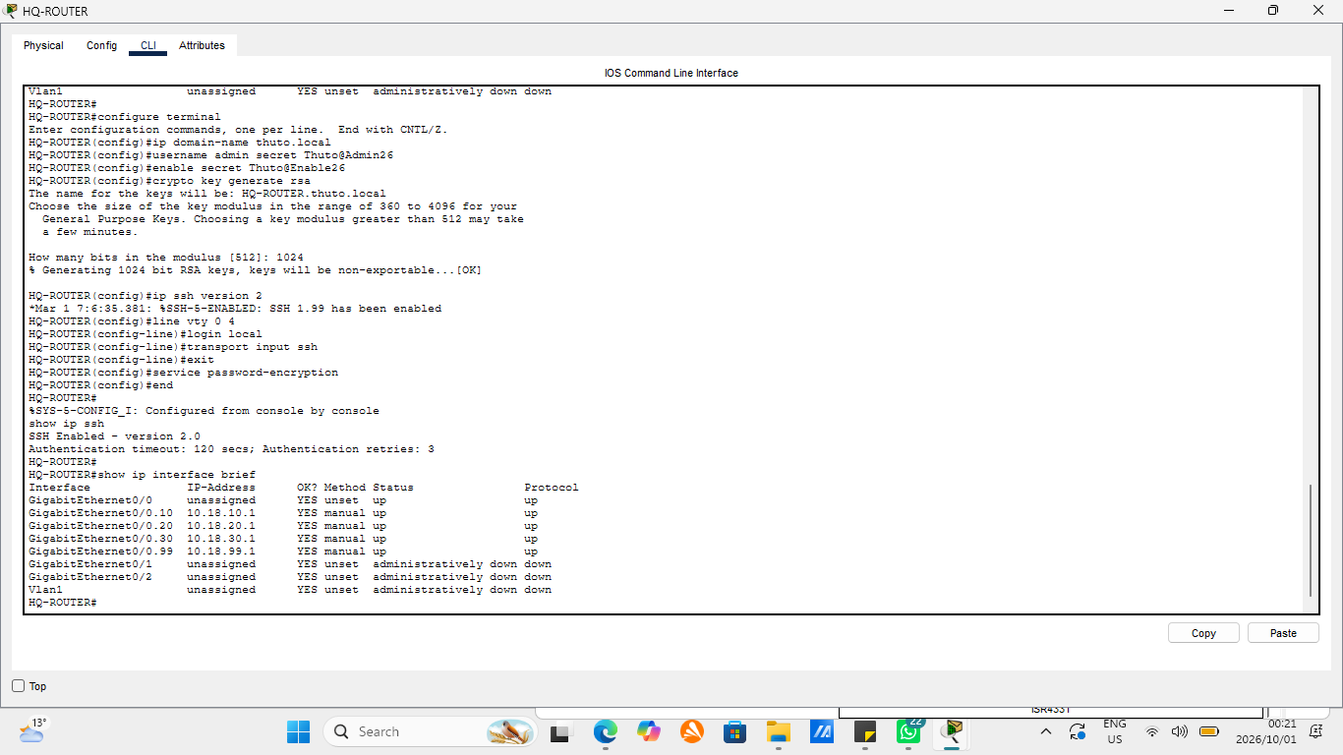
Figure 8: show ip interface brief on HQ-ROUTER (M2-11)

9. Design Constraint and Change Request
9.1 Design constraint: Boardroom requires dedicated wireless and wired presentation ports.
The wired port is the Board PC on ACCESS-SW Fa0/9. The wireless port is BOARD-AP on Fa0/8, with the SSID Thuto-Boardroom secured with WPA2-PSK and AES. The Board Laptop connects to the access point wirelessly. Both ports are in VLAN 30.
9.2 CR9: One off-site administrator requires secure remote management access to network devices.
SSH version 2 was enabled on HQ-ROUTER, CORE-SW and ACCESS-SW. Each device has a management address in VLAN 99, a local administrator account, an enable secret and a 1024-bit RSA key. The virtual terminal lines accept SSH only, so Telnet is refused. Passwords are stored encrypted.
Commands used on each device:
ip domain-name thuto.local
username admin secret <password>
enable secret <password>
crypto key generate rsa
ip ssh version 2
line vty 0 4 (line vty 0 15 on the switches)
login local
transport input ssh
service password-encryption
The switches also received a VLAN 99 interface and a default gateway, for example on CORE-SW:
interface vlan 99
ip address 10.18.99.2 255.255.255.0
no shutdown
ip default-gateway 10.18.99.1
Admin PC1 acts as the administrator’s workstation and reaches the VLAN 99 addresses through the router. Packet Tracer cannot simulate a true off-site connection without adding scope the brief does not include, so Admin PC1 stands in for the remote administrator. A Telnet attempt to 10.18.99.1 was closed by the router without a login prompt, showing that only SSH is accepted.
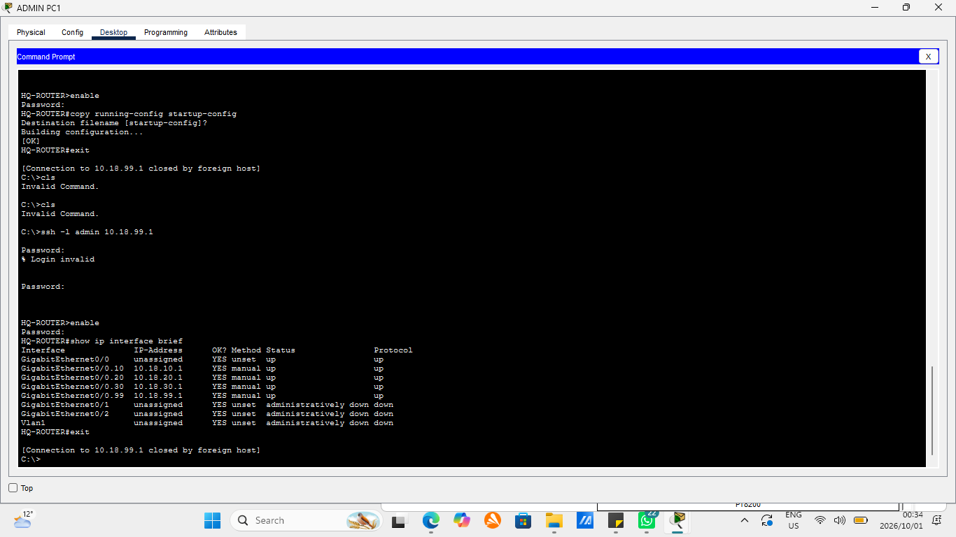
Figure 9: SSH login to HQ-ROUTER (M2-13)
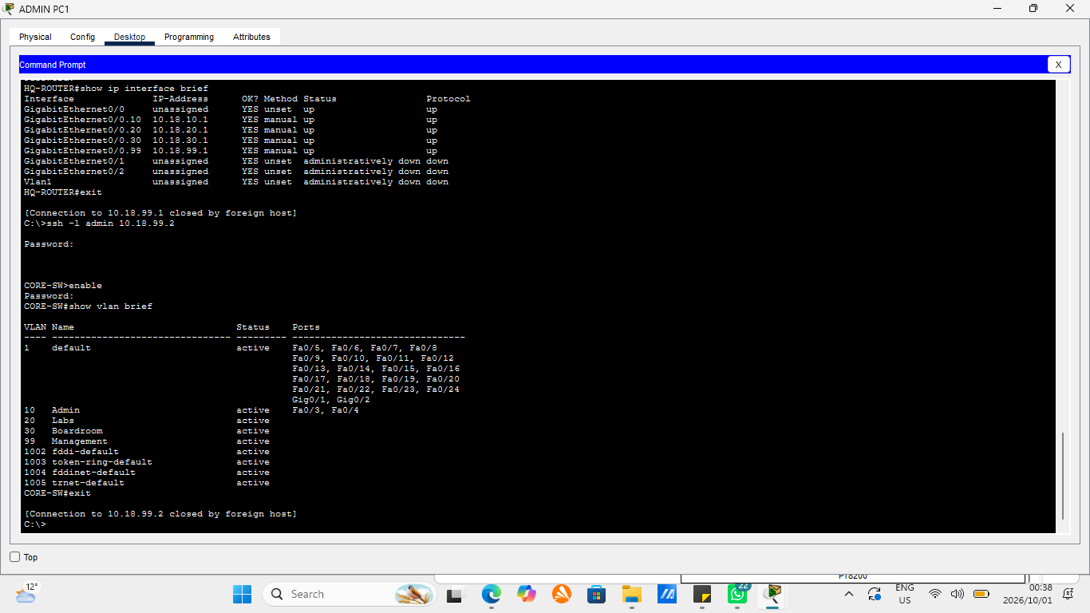
Figure 10: SSH login to CORE-SW (M2-14)
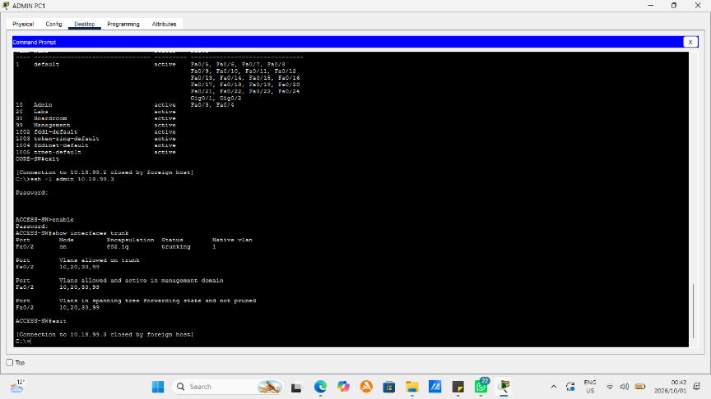
Figure 11: SSH login to ACCESS-SW (M2-15)
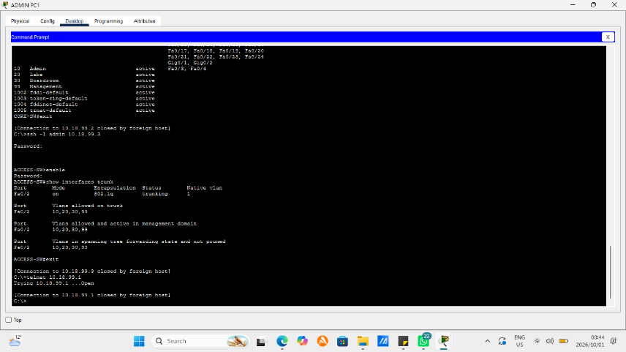
Figure 12: Telnet attempt refused (M2-16)

10. Testing Evidence
Test | Source to destination | Result | Evidence
Same VLAN | Admin PC1 to Admin PC2 (10.18.10.11) | 4/4 replies, TTL 128 | M2-17
Between VLANs | Admin PC1 to Lab PC1 (10.18.20.10) | Replies, TTL 127 | M2-18
Between VLANs | Lab PC1 to Board PC (10.18.30.10) | Replies, TTL 127 | M2-19
Wireless to wired, same VLAN | Board Laptop to Board PC (10.18.30.10) | 4/4 replies, TTL 128 | M2-20
Wireless to another VLAN | Board Laptop to Admin PC1 (10.18.10.10) | 4/4 replies, TTL 127 | M2-21
Path check | tracert from Admin PC1 to Lab PC1 | Hop 1 is 10.18.10.1 (router), hop 2 is Lab PC1 | M2-22
A TTL of 128 means the packet stayed inside one VLAN. A TTL of 127 means the router routed it and subtracted one. On routed tests the first packet sometimes timed out while devices learned each other’s addresses and the remaining packets succeeded. Wireless pings showed higher response times than wired ones, as expected over an access point.
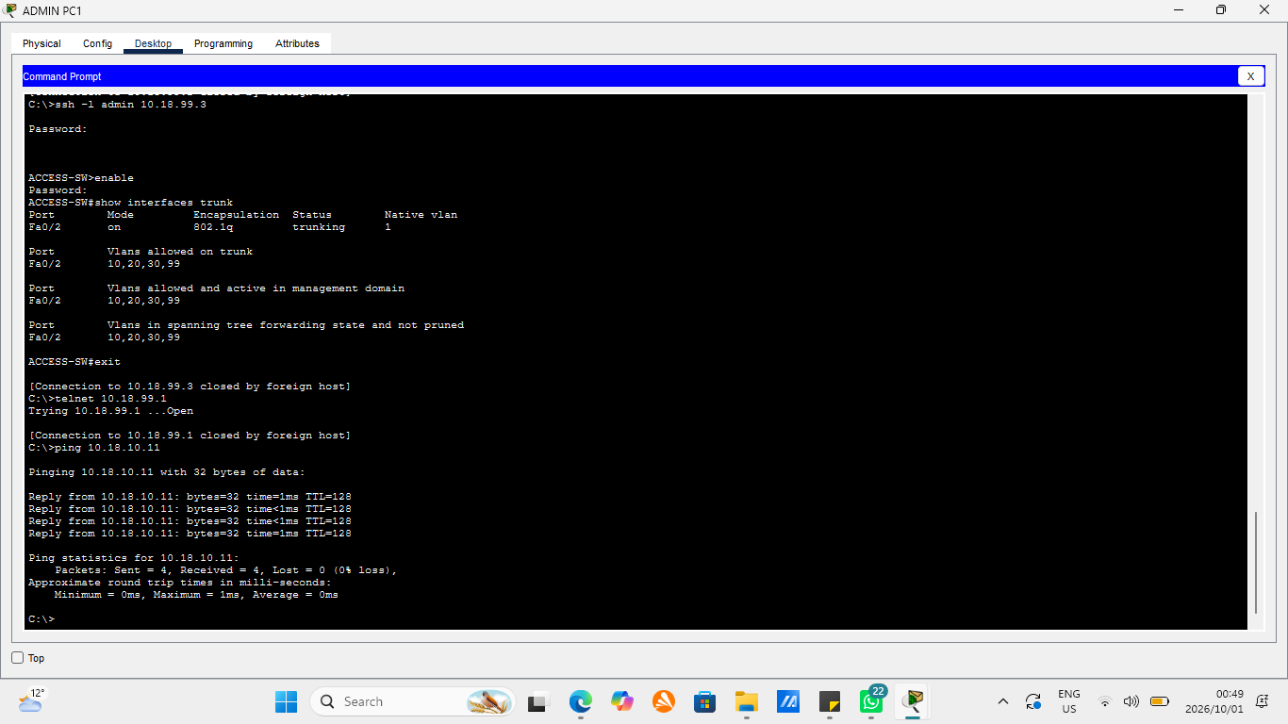
Figure 13: Ping Admin PC1 to Admin PC2 (M2-17)
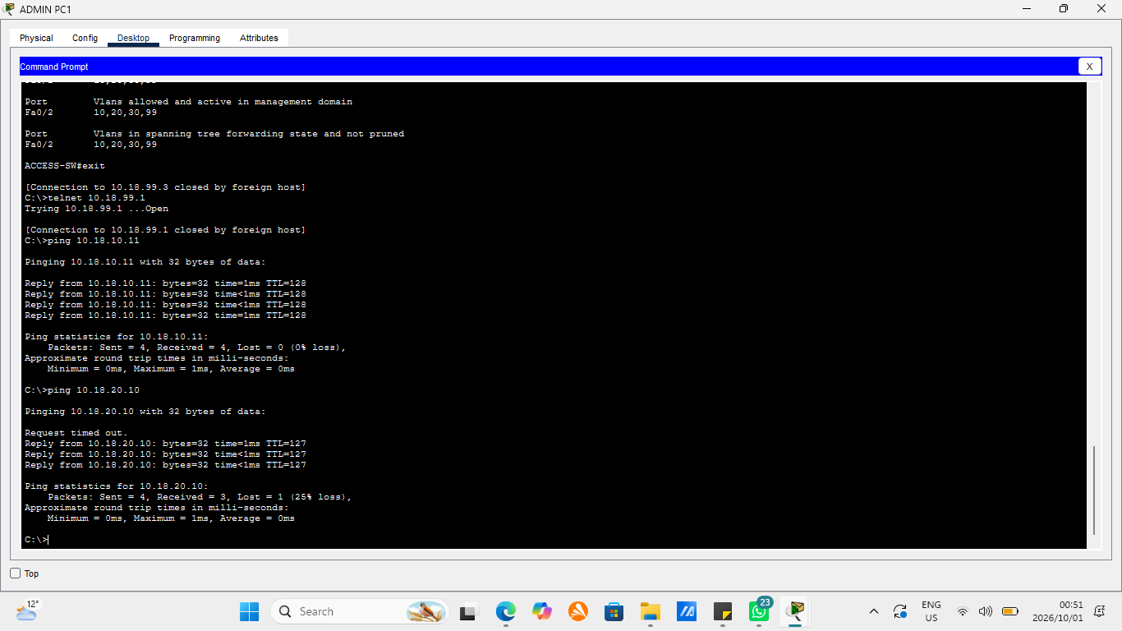
Figure 14 : Ping Admin PC1 to Lab PC1 (M2-18)
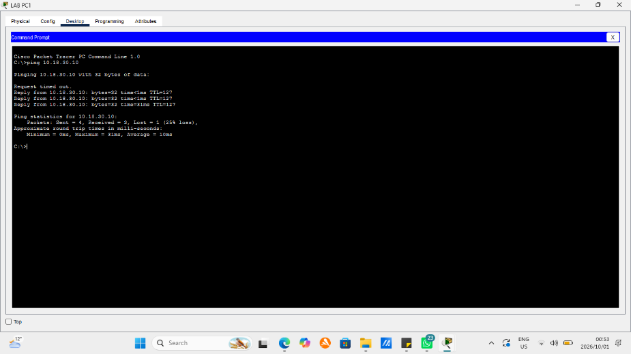
Figure 15 : Ping Lab PC1 to Board PC (M2-19)
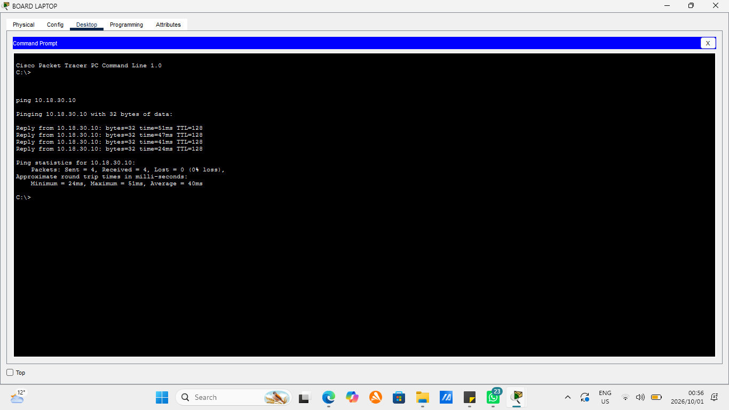
Figure 16 : Ping Board Laptop to Board PC (M2-20)
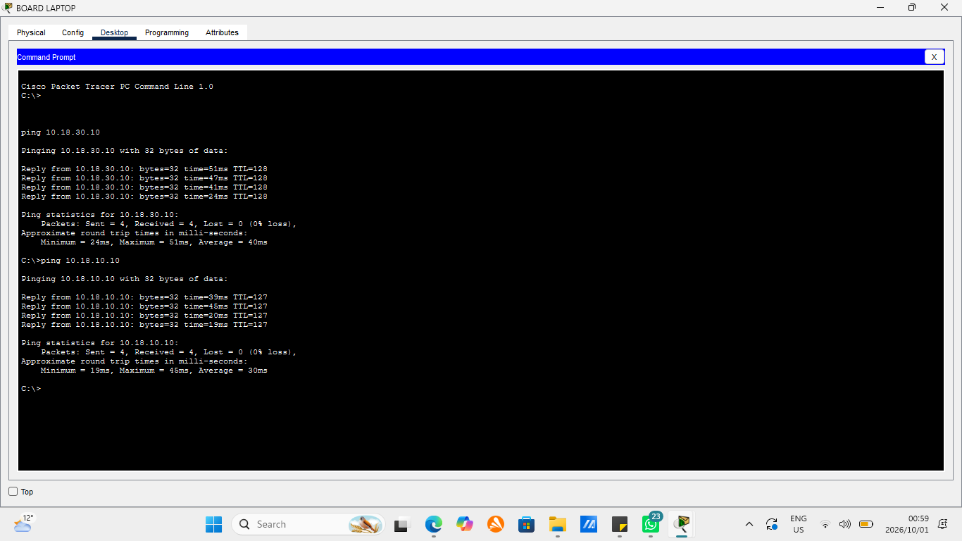
Figure 17: Ping Board Laptop to Admin PC1 (M2-21)
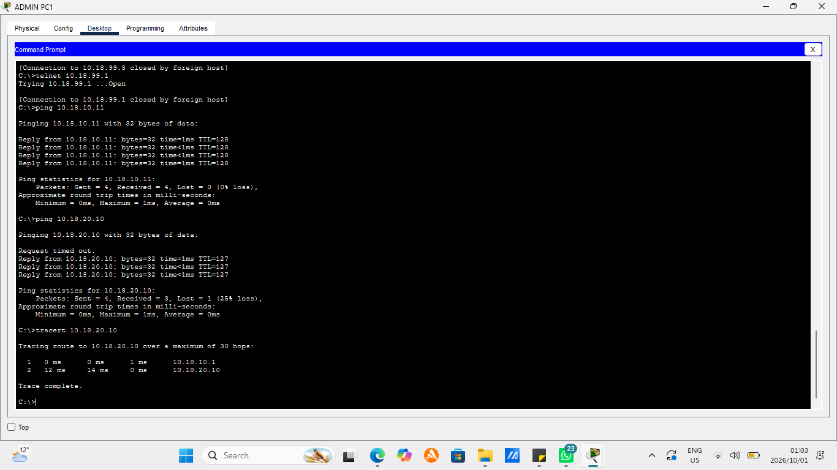
Figure 18 : Tracert Admin PC1 to Lab PC1 (M2-22)

11. Troubleshooting Performed
- Spanning-tree warning on the trunk. After the trunk was configured on CORE-SW, ACCESS-SW reported “Received 802.1Q BPDU on non trunk FastEthernet0/2” and an inconsistent port type, and only VLAN 99 appeared in the forwarding list. The two ends disagreed because ACCESS-SW Fa0/2 was still an access port.
Fix: configure the matching trunk on ACCESS-SW. After the link settled show interfaces trunk listed VLANs 10, 20, 30 and 99 as forwarding.
- SSH command typed incorrectly. The command returned “Invalid Command” because it was typed as ssh -1 instead of ssh -l.
Fix: retype it with the letter L.
- Failed SSH logins. Several attempts returned “Login invalid” or timed out at the password prompt because of incorrect password entry.
Fix: retry promptly with the correct password, after which the login to HQ-ROUTER succeeded.
- Management address rejected on CORE-SW. The ip address command on the VLAN 99 interface returned “Invalid input” because part of the address was dropped when typed.
Fix: re-enter the command by hand in interface configuration mode. show ip interface brief then showed Vlan99 as 10.18.99.2, up/up.

12. Reflection and Conclusion
This project taught me how to turn network requirements into a working, tested solution. I learned the importance of proper planning, documented assumptions and structured IP addressing, as well as how 802.1Q trunking carries multiple VLANs and how verification commands help identify configuration errors. Setting up SSH for CR9 also taught me to pay attention to detail and check each command carefully. In conclusion the network meets the requirements with VLAN segmentation, trunking between switches, router-on-a-stick inter-VLAN routing, wired and wireless boardroom presentation ports and secure SSH management with testing confirming connectivity within and between VLANs.

